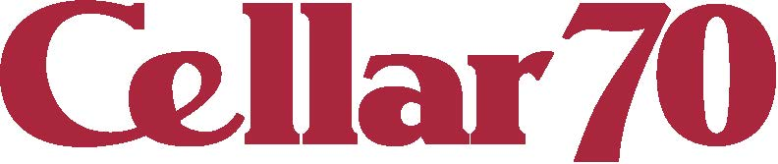
NAME:
NUMBER:
REGULAR SALE BTL
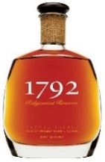
PRICE PRICE QTY

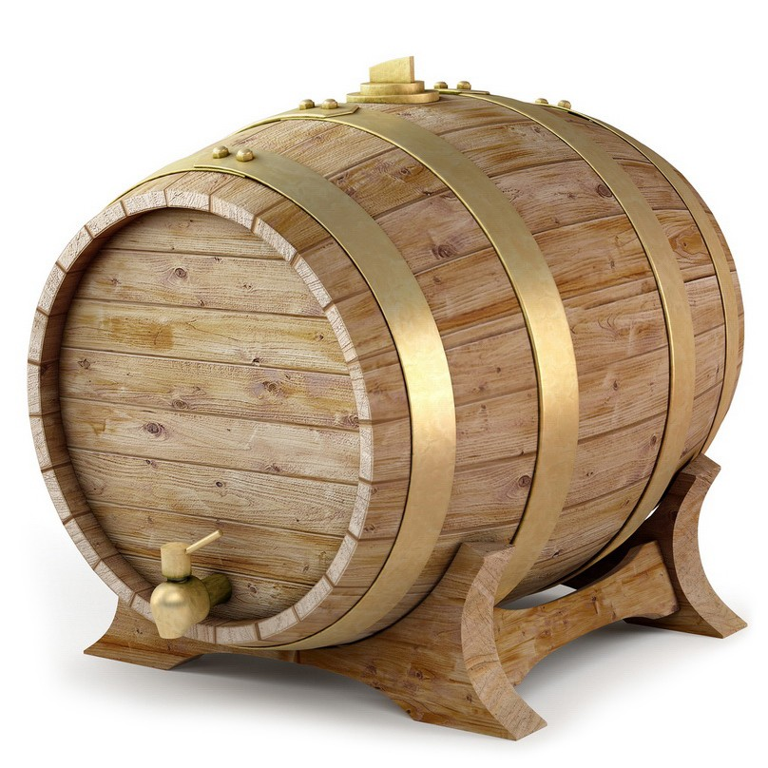
1792 BOURBON 750ML $26.99 $22.99

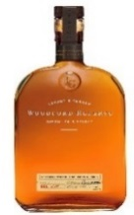
WOODFORD RESERVE $39.99 $29.99
BOURBON 750ML

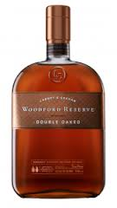

WOODFORD RESERVE $55.95 $44.99
DOUBLE OAK BOURBON 750ML
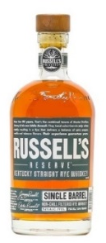

RUSSELS RESERVE SINGLE $49.99 $44.99
BARREL BOURBON 750ML

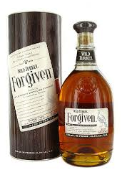

WILD TURKEY FORGIVEN $49.99 $44.99
BOURBON 750ML

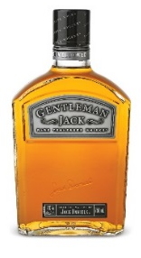

GENTLEMAN JACK $44.99 $34.99
TENNESSEE WHISKEY 1LTR
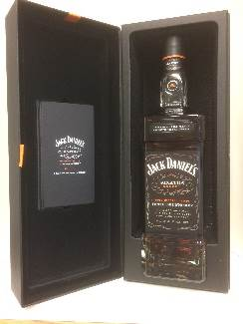

JACK DANIEL’S SINATRA $199.99 $149.99
SELECT 1LTR

