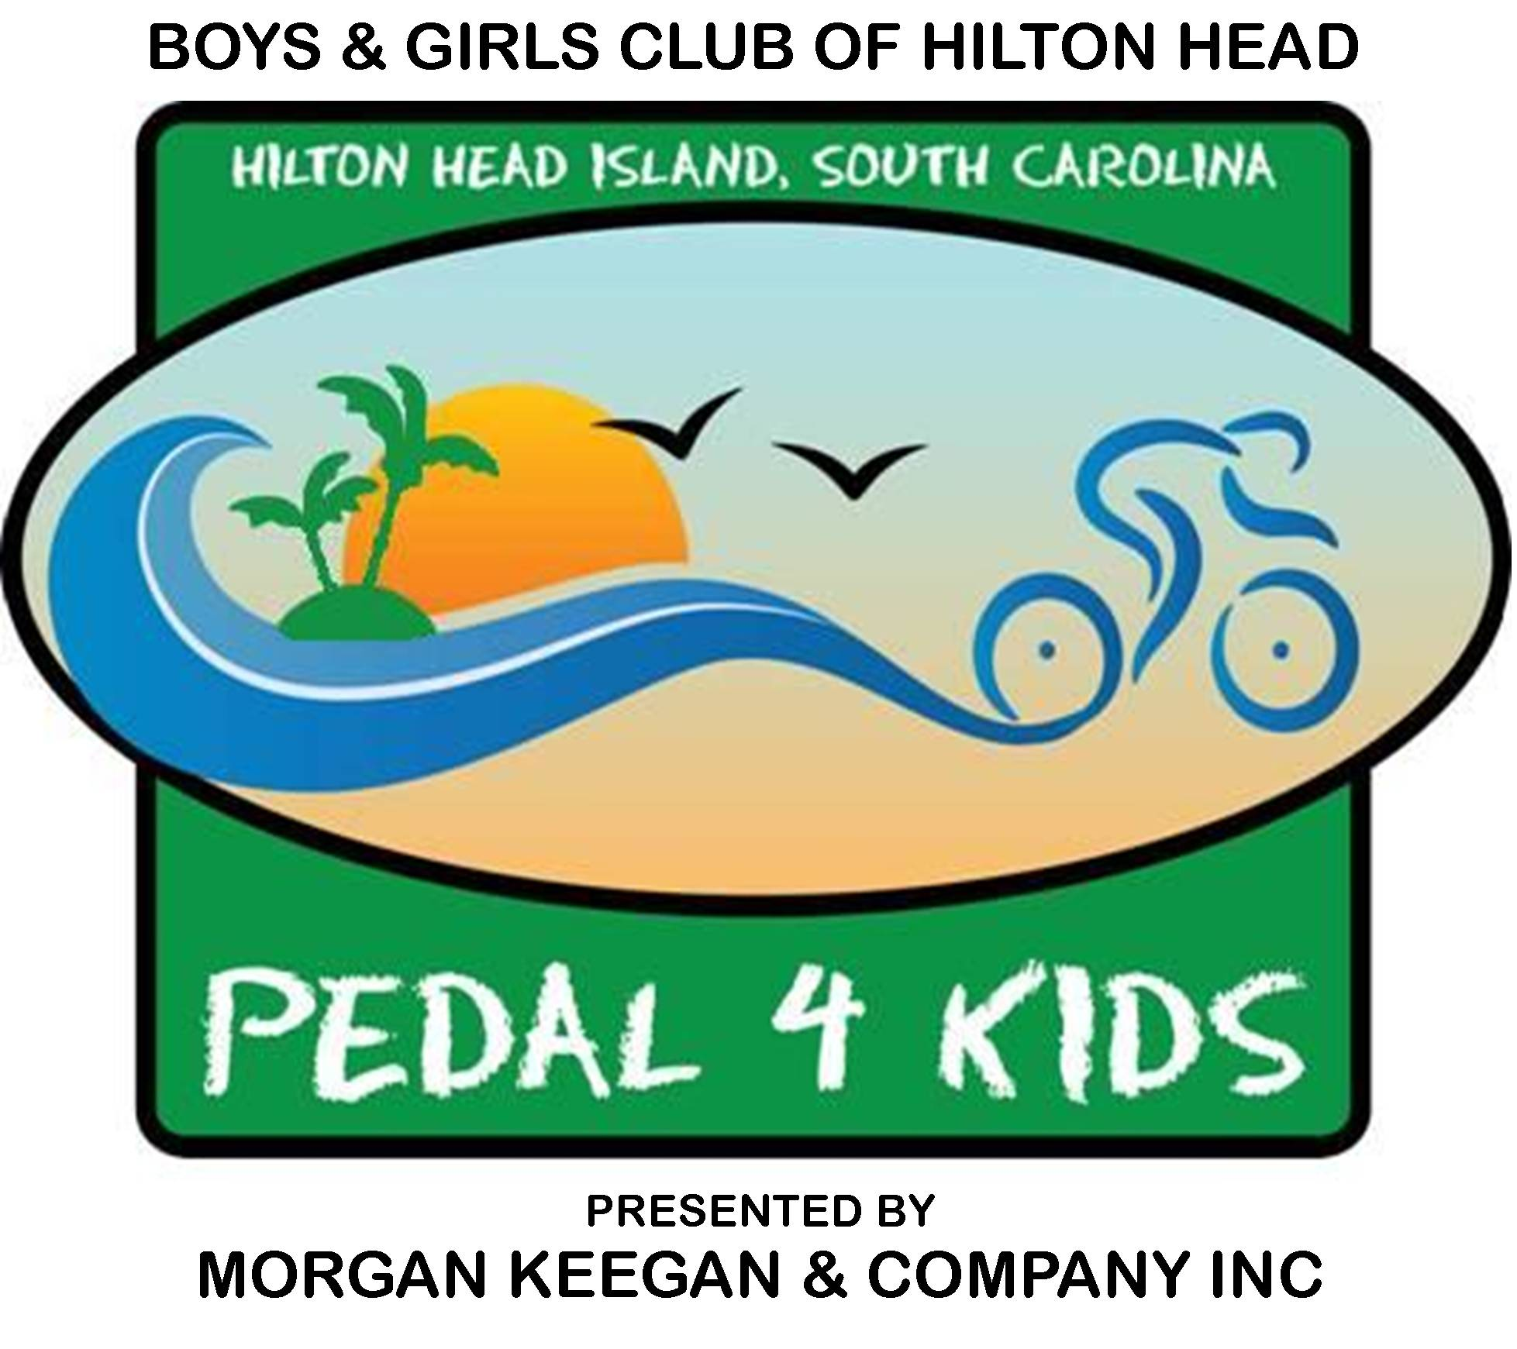

Volunteer Form

Volunteers will be needed to support the Boys & Girls Club Pedal 4 Kids Bike Ride from approximately 6:00 AM to 1:00 PM on Saturday, September 26, 2009, at Hilton Head High School and/or to help set up for the event on the evening of Friday, September 25. Please select the area and time you prefer below and a volunteer coordinator will call you. Thanks from the Hilton Head Boys & Girls Club for your support of our mission!

Volunteer Areas and Times

□ Anywhere I’m needed on ride day, Saturday, September 26

□ Set up on Friday, September 25 from 4:00 to 7:00 PM
□ Set up on Saturday, September 26 from 6:00 to 9:00 AM
□ Registration and packet pickup at Hilton Head High School on Saturday, September 26 from 6:30 to 9:30 AM
□ Morning event support on Saturday, September 26 from 8:00 AM to noon
□ Late morning and early afternoon clean up and tear down on Saturday, September 26 starts 11:00 AM
□ Other ____________________________________________________

Volunteer T-Shirt Size (each volunteer will receive a free Pedal 4 Kids T-shirt)

□ Small □ Medium □ Large □ XL

I AM UNABLE TO VOLUNTEER BUT WANT TO MAKE A CONTRIBUTION! ENCLOSED IS MY GIFT OF $ _____________________
Name ________________________________________________________________
Address ______________________________________________________________
City State Zip __________________________________________________________
Daytime Phone ______________________ Evening Phone _____________________
E-mail ________________________________________________________________
Best time to contact me is _________________________________________________

Please return this volunteer form to Douglas Barry at the Hilton Head Boys and Girls Club, PO Box 22267 Hilton Head Island, South Carolina 29925 • Fax to 843 689-2618 or • E-mail dbarry@bgchhi.org • call 843-689-3646 for additional information

